**C++ LIBRARY MANAGEMET SYSTEM PROJECT**

**CONTENTS:**

1. ABOUT THE PROJECT
2. WHAT IS LIBRARY MANAGEMENT SYSTEM?
3. FEATURES OF LIBRARY MANAGEMENT SYSTEM IN C++
4. WORKING OF PROJECT (USER MANUAL)

* Main menu screen
* Student access
* Librarian access

1. PROJECT ALGORITHM IN SHORT
2. STEPS TO RUN THE PROJECT
3. **ABOUT THE PROJECT**

|  |  |
| --- | --- |
| **ABOUT THE PROJECT** | **PROJECT DETAILS** |
| **Project name:** | Library Management System |
| **Project platform:** | C++ |
| **Language used:** | C++ |
| **Developers:** | Negasa Reta |
|  |  |
|  |  |
|  |  |

1. **WHAT IS LIBRARY MANAGEMENT SYSTEM?**

As the name suggest the Library Management System is a software which handles the entire data of library. It makes the work of librarian very easy instead of writing data in a notebook. In past the librarians were using notebooks to write the data of books. So it was very difficult to keep track on each and every book. If librarian wants to search for a particular book then that task was very time consuming. So to make this task easy the programming languages were developed and C++ language is one of them.

1. **FEATURES OF LIBRARY MANAGEMENT SYSTEM PROJECT IN C++**

We have created separate logins for students and the librarian, in which the librarian is password protected. In this project, the librarian can **add, update, delete, display** the books in the library, and **can search** the book as per needed. The students can also view the list of the books available in the entire library database, can search the book they need to read or enjoy by suggesting either the title of the book or the book id number. The entire rights are given to the librarian to adding books and modify the book.

**This project uses FILE HANDILING to store the data of books in a project.** A Librarian can also be able to change the password. Modules of Library Management System

**For librarian:**

* Add Book
* Modify/Update Book.
* Delete Book.
* Admin password reset

**For both librarian and student:**

* Search Book
* Display the book in the data base

1. WORKING OF THE PROJECT

We have displayed the menu of Student, Librarian and close the application. If you’re a librarian then your choice will be 1 and if you are a student then your choice will be 2, if you want to know the information about the project your choice will be 3, and the another possibility is to quit the application by pressing choice 4. Now we’ll discuss each and every menu in details.

**The main menu screen:-** When you run the project from a compiler you will see the following screen shown in the picture.

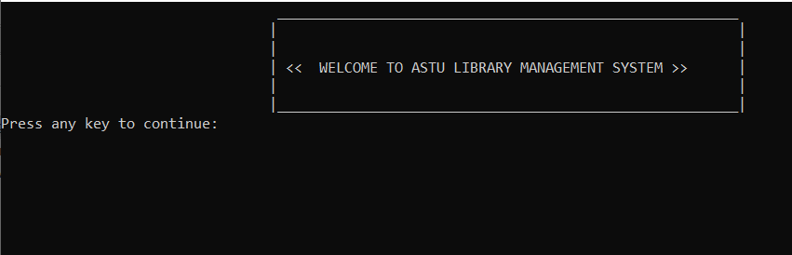

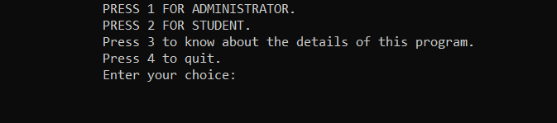Figure 1 Main menu

Figure 2 Choice Menu

**1. Student**

The student will not require additional sign in, he or she will be able to access the software directly. When the user enter choice 2 (shown in figure 2 ) the following will appear.

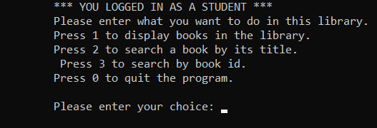

Figure 3 student menu

**To display books in the library:** In this menu option all the students will be able to view the books present in the database along with their details.

**To search a Book:** We have given access to the students to search for a particular book. The a student can search a book either by book title – choice 2, or by book id - choice 3. Both the options are available in the project.

**Go to Main Menu:** When the user has done the required operations and if he want to again moveto the main menu, then he’ll moved to the main menu.

**Close Application:** By pressing the choice as 0 the application will be closed.

**2. Librarian:**

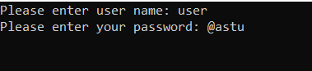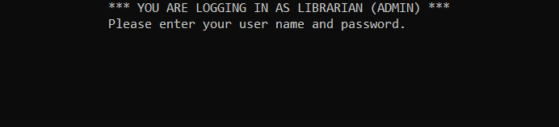To access the features of the librarian menu, He will require to sign in using the admin username (which is **“user**”) and password (**which is “@astu”**)**.** We’ve also given the facility to change the password in the Librarian menu. Only Librarian has rights to change the password. When the user press the choice as 1 then the software will ask you to enter the correct password as shown in the following figure.

Figure 5 Admin menu 2

Figure 4 Admin (librarian) menu 1

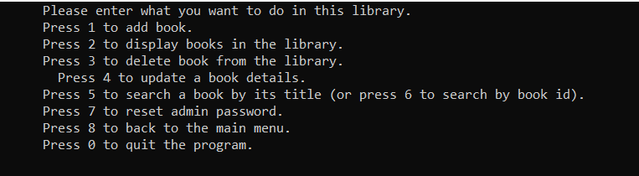If the password is incorrect the application will show the error of wrong password. And if the password is correct then the librarian menu will be visible to the user where he or she can do the operations displayed in the menu (figure 6).

Figure 6 Admin menu 3

**View Booklist:** Same as students view booklist, librarians will also able to see the books available in thelibrary database.

**Search For a Book:** The Librarian can search book either by book name or by book id. Both the options are available in the project.

**Modify/Add Book:** In this menu option Librarian can do three main operations i.e. Adding a Book,Deleting a Book and Modifying (updating) the existing Book. **In the addbook** option the admin is required to enter the important features of the book as per he is asked, like book title, book author, book isbn, and number of pages in the book. If the words are two or more the user have to use underscore (**_**) to distinguish the two words. As we are using the **file handling** methods in this project, every time new fileis generated to store the details of the books. i.e. library_mgt_record.txt.

1. **PROJECT ALGORITHM IN SHORT**

Algorithm for a library management system C++ project using a structure and file handling:

1. Include different header files:

* <iostream> : To use input and output stream
* <string>: To use different string functions
* <chrono>: provides a set of classes and functions for measuring time duration and time points.
* <fstream>: header file to use file handling
* <thread>: provides a set of classes and functions for creating and managing threads

1. Create a **structure** named **Library** with the following attributes:
   * **string title**: name of the book
   * **string author**: name of the author
   * **string id**: unique identifier for each book
   * **string isbn**: ISBN number of the book
   * **int page**: the number of pages in the book
2. Create a variable **book** with the **Library** data type to access each element of the Library structure. i.e.,

* book.title
* book.author
* book.isbn, … etc.

1. Implement the following methods (functions) in the book structure:
   * **addbook()**: adds a new book to the library
   * **deletebook()**: removes a book from the library
   * **search_book_by_title()**: searches for a book in the library by its title
   * **search_book_by_id()**:searches for a book in the library by its id
   * **display()**: displays all the books in the library
   * **write_to_file():** writes the admin password and username once
   * **update()**: to update the book features
   * **resetpassword()**: to reset the admin password
   * **about_this_project():** to display information about the project (about the project)
2. Create a file named **library_mgt_record.txt** to store the book records and a file named **administrator_book.txt** to store the user name and password of the admin(librarian).
3. Use **switch statement** to give alternative choices
4. Use **if else statement**  to test for different conditions
5. **STEPS TO RUN THE PROJECT**
6. Extract the zip file (named “**NEGASA’S GROUP C++ PROJECT**”**)**
7. Open the file using C++ compiler such as Dev C++ or CodeBlocks
8. The project has no error, if found then correct it.
9. Now run the project.

THIS SIMPLE C++ LIBRARY MANAGEMENT SYSTEM PROJECT CAN SIMPLIFY LIBRARIANS WORK EFFICIENTLY SINCE IT USES FILE HANDILING APPROACH.

=======THANK YOU, THE PROJECT DEVELOPER; DECEMBER, 2023!======